Magnus Effect
Hello Jussties, how’s the day going hope its great. Have you ever thought why some balls follow a curved path in air, tennis, cricket and football players experience this.In old days some bowlers scratch any particular side with accessories like ring etc, but it’s illegal, to make the ball swing, you must have seen freekicks in footballs in which the players kick the ball in a way that it bends its path and this is nicknamed as “Banana Shot”, in tennis they say that they chop the ball which really doesn’t mean that they are cutting the ball into pieces but it means that they are curving the trajectory(path followed by an object)of the projectile(the object which is thrown or in motion). All this is due to Magnus effect, “So first of all what is Magnus effect?” This is what you right? I got you

Magnus Effect:
It is a phenomenon that is commonly associated with a spinning object moving in a fluid medium. It is a manifestation of Bernoulli’s theorem
Let me try to convey this in a lucid language as usual let’s assume a football is kicked by a professional player say you, in a way that it spins in clockwise direction and air flows in the opposite direction.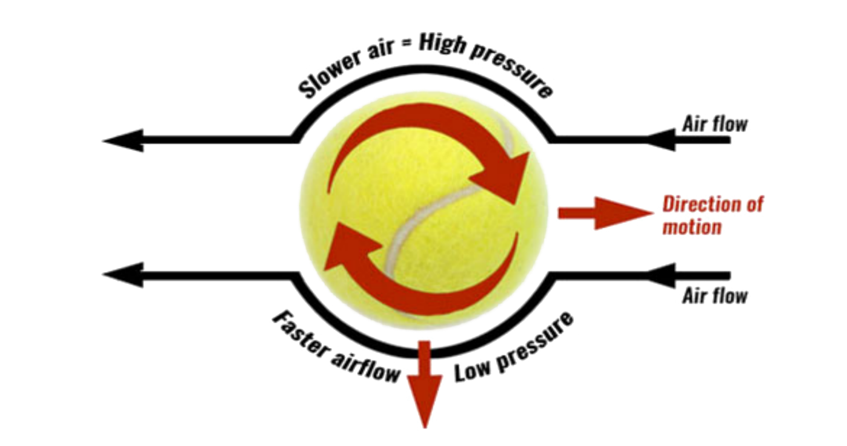
Credits for the pic: TeachPE.com
Due to the drag of the air (as the wind is in opposite direction an opposite force is acted on the projectile) the speed at the upper side of the ball decreases and the speed at the lower side increases, because of this a pressure difference increases. We know that the Bernoulli’s theorem states that if the speed of the fluid is less then high pressure is created there if the speed increases then low pressure is created. This pressure difference exerts a force on the object and curves its path. In our case it bends downward. This is known as Magnus effect. Now some of you couldn’t figure out why the pressure decreases,let me clarify it with another example, sometimes when you stand near the track in a metro or railway station when the locomotive or the train passes you with high speed you might feel something behind you pushing you towards the track, the same acts here(But please don’t try this at any circumstance).
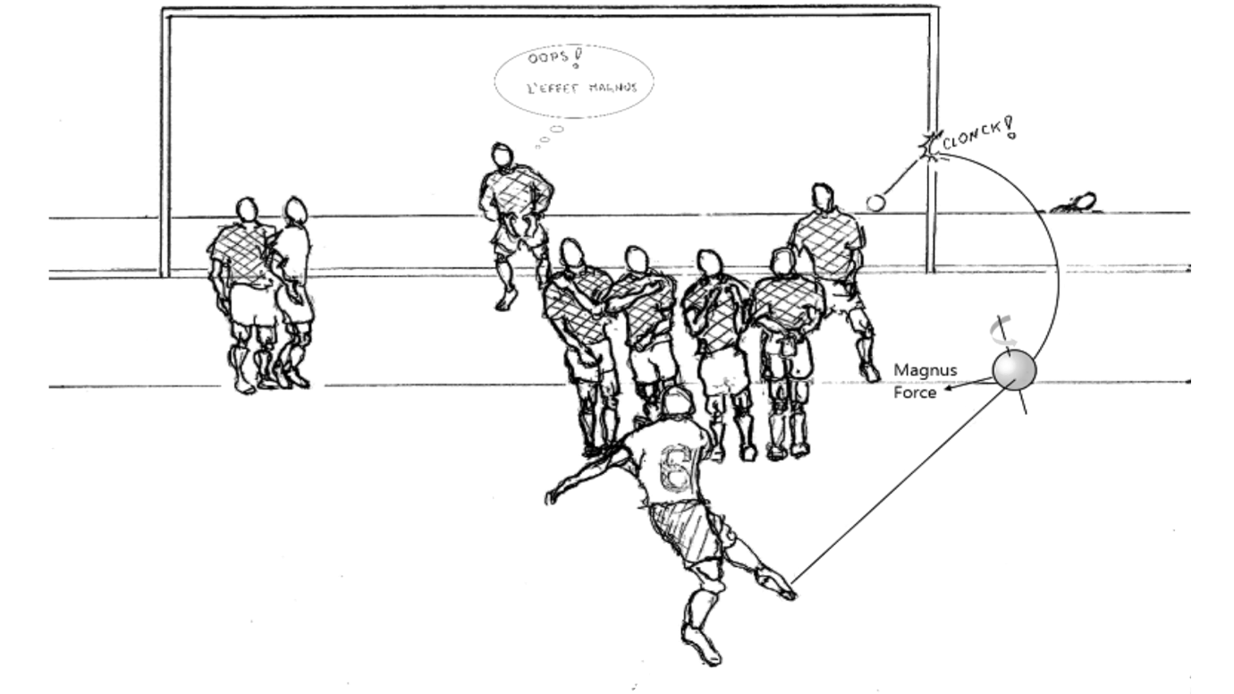
Credits for the pic: COMSOL
For the first time in the history of football in the match of France VS Brazil in 1997 a player named Roberto Carlos made a kick in which the ball curved as illustrated above. The Audience were stunned on seeing this and till now no one could make a banana shot as good as Carlos. At last a fun fact Roberto Carlos has also played in Indian Super League for one season in 2015 and he had also acted as a player manager for Delhi Dynamos and led them to playoffs.
Thank You

